It contains information on toxic chemicals handled by many facilities across the United States, including details on quantities of chemicals managed through disposal or other release, recycling, energy recovery or treatment

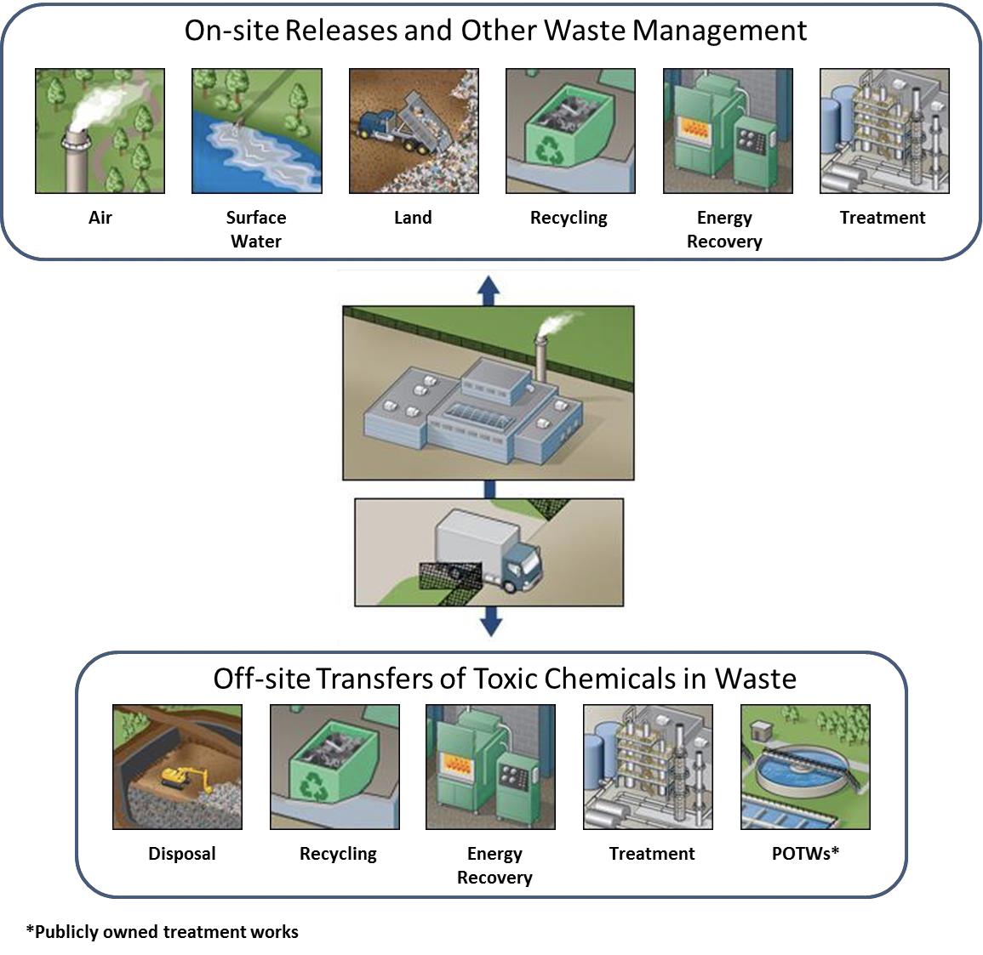

Group by Industry Sector and see which sector contributes to the most and least of changes in house variations ----

See Housing Rates variations

Observe the house variations in different categories of housing – condo, bottom tier, top tier, 1-bedroom,2-bedroom, etc

Observe the house variation that is seen most varied:

1. Most Depreciating graph caused by which industry sector
2. Most Progressive/Improvement is seen in which industry sector

The changes in housing values depending on

On Site Releases and Other Waste Management

1. Air
2. Surface Water
3. Land
4. Recycling
5. Energy Recovery
6. Treatment

Off-site Transfers of Toxic Chemicals in Waste

1. Disposal
2. Recycling
3. Energy Recovery
4. Treatment
5. POTWs

These can be checked for one state initially, then can be applied to other states or to the US file as a whole

We need to compare the TRI_YYYY_XX.csv file with ZIP_ZHVI_XXXX.csv (bottom tier, top tier, condo,1-bedrm,2-bedrm..) files to deduce the correlations between those features.

Here, we need to load data from TRI-for a range of years – in order to see the variation of housing over that period of years.